**Project Design Phase-II**

**Technology Stack (Architecture & Stack)**

|  |  |
| --- | --- |
| Date | 16 October 2022 |
| Team ID | PNT2022TMID52458 |
| Project Name | DEMANDEST-AI POWERED FOOD DEMAND FORECASTER |
| Maximum Marks | 4 Marks |

**Technical Architecture:**

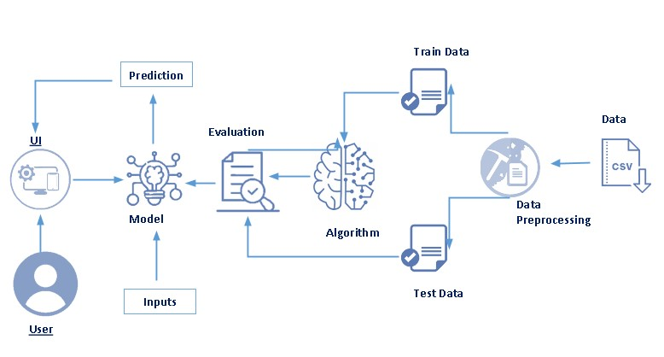

**Table-1 : Components & Technologies:**

|  |  |  |  |
| --- | --- | --- | --- |
| **S.No** | **Component** | **Description** | **Technology** |
| 1. | User Interface | User access to the application through mobile application | HTML |
| 2. | Application Logic-1 | Creating an application interface | Python |
| 3. | Application Logic-2 | Creating an AI assistant that gives food service to the user | IBM Watson Assistance |
| 4. | Application Logic-3 | Files are stored in the local storage and stored in the cloud | IBM Watson Assistant |
| 5. | File Storage | File storage requirements | IBM Block Storage or Other Storage Service or Local Filesystem |
| 6. | External API-1 | Purpose of External API used in the application | IBM Location REST API, etc. |
| 7. | Deep Learning Model | Creating an algorithm to calculate case information provides by the fulfillment center | Object Recognition Model, etc. |
| 8. | Infrastructure (Server / Cloud) | IBM Cloud App Configuration is a centralized feature-management and configuration service on IBM Cloud. | Local, Cloud Foundry, Kubernetes, etc. |

**Table-2: Application Characteristics:**

|  |  |  |  |
| --- | --- | --- | --- |
| **S.No** | **Characteristics** | **Description** | **Technology** |
| 1. | Open-Source Frameworks | This application has no open-source frameworks. | Python |
| 2. | Security Implementations | Block chain technology is utilised to implement security since its private structure safeguards all data.. | Blockchain |
| 3. | Scalable Architecture | Users can acquire food services online, as well as information about the most popular products. In this strategy, customers profit from evaluating their industry data, which gives predictions on day-to- | IBM cloud |
| **S.No** | **Characteristics** | **Description** | **Technology** |
|  |  | day analysis of food sold and reduces food waste by projecting sales movements. |  |
| 4. | Availability | Data is updated here, and demand is forecasted based on the data. | IBM Watson Assistant |
| 5. | Performance | The geo-fencing algorithm is updated everyday and displays the contaminated zones' day-to-day updates. | Geo Fence |